**RESULTS AND DISCUSSION**

The Multiple Intelligence classification is a multiclass classification problem with a total of 8 classes. These 8 classes and the number of records we have for each class in our dataset can be seen in the graph 01. The algorithm was created for calculating the multiple intelligence based on the responses to 40 questions given by the students through the survey. The processed data was fit on the created algorithm and the predicted intelligence is noted in a separate column in our dataset. The maximum accuracy noted by performing the stratified k-fold cross validation is 100% and the mean accuracy is 88.5%. The training accuracy is noted at 88.49%.

*Graph 01: Value count of MI types*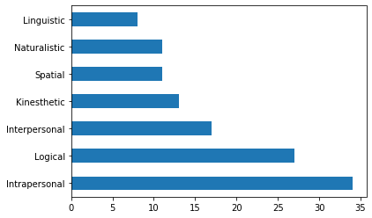

The confusion matrix for the training set can be seen in the graph 02. The confusion matrix present here is an 8x8 confusion matrix as our problem is a multiclass classification problem with a total of 8 classes. The diagonal row of the boxes in the confusion colored in multiple colors are all the true positive values. For the training set we have a good number of true positive values with a 100% accuracy for 7 multiple intelligence types but a 0% accuracy for one of the 8 MI types.

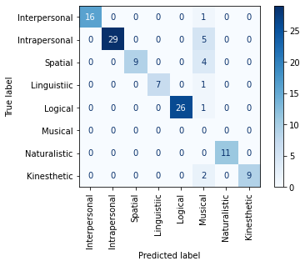

*Graph 02 : Training prediction confusion matrix*

A similar behavior can be observed in the confusion matrix of the cross validation set or the test set with a lesser number of records. We can see the 100% accuracy or all predictions a true positive for the same 7 MI types as in the train set in the confusion matrix, and 0% accuracy for the remaining 1 MI type as observed in the training set also. The final test accuracy of the algorithm or the mean accuracy is found to be 88.5% with the maximum accuracy as 100%.

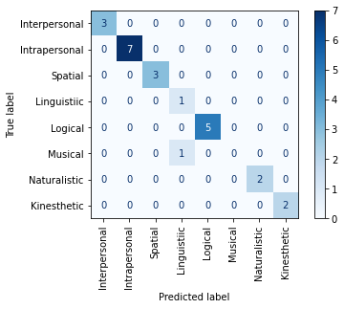

*Graph 03 : Cross-validation confusion matrix*

The accuracy of the cross validation sets can be seen as below. The minimal accuracy observed is 79.16% and the maximum accuracy as 100%.

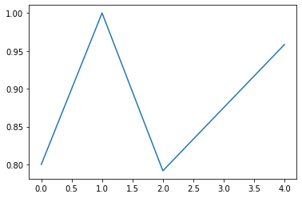

*Graph 04: Accuracy*

The accuracy of the model can be improved more by feeding larger dataset to the model. The dataset used for these results seems little biased towards certain MI types and is therefore influencing the predictive power of the algorithm. The larger and more balanced dataset will be capable of treating this problem and will yield much better accuracy.